PRODUCT LIST

PRODUCT | PICTURE | DEALER  PRICE | WHOLESALE PRICE | SUGGESTED  RETAILPRICE  (S.R.P.)

STREETLIGHTS
XL-15W  15W  Daylight  Warm White  5years warranty |  | 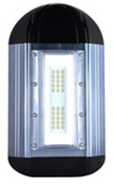 | 2,010 | 2,412 | 2,684.75
XL-30W  30W  Daylight  Warm White  5years warranty | 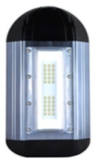 |  | 3,617 | 4,340 | 4,824.75
XL-60W  60W  Daylight  Warm White  5years warranty |  |  | 7,234 | 8,680 | 9,644.75

FLOOD LIGHTS
XT-15W  15W  Daylight  Cool White  Warm White  5years warranty | 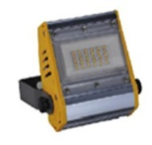 | 1,914 | 2,297 | 2,554.75
XT-30W  30W  Daylight  Cool White  Warm White  5years warranty | 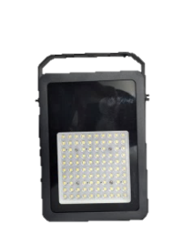 | 3,617 | 4,340 | 4,824.75
XT-60W  60W  Daylight  Cool White  Warm White  5years warranty | 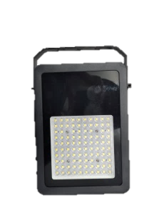 | 7,232 | 8,679 | 9,644.75
XT-120WB  120W  Daylight  Cool White  Warm White  5years warranty | 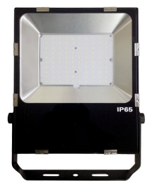 | 11,543 | 13,851 | 15,394.75
XT-180WB  180W  Daylight  Warm White  5years warranty |  | 17,314 | 20,777 | 23,084.75

HI-BAY
XD-30W  30W  Daylight  Cool White  5years warranty | 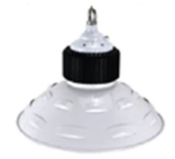 | 3,617 | 4,340 | 4,824.75
XD-60W  60W  Daylight  Cool White  5years warranty | 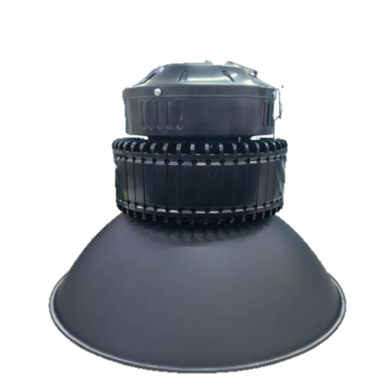 | 7,232 | 8,679 | 9,644.75
XD-120W  120W  Daylight  Cool White  Warm White  5years warranty |  | 11,543 | 13,851 | 15,394.75
XD-180W  180W  Daylight  Cool White  Warm White  5years warranty | 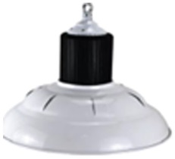 | 17,314 | 20,777 | 23,084.75

TUBELIGHTS ( ONE SIDED )
ET8A-16WQ  T8/1.2M/16W  Daylight  Cool White  Warm White  5years warranty | 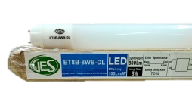  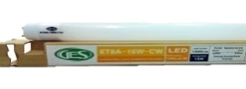 | 603 | 722 | 804.75
ET8B-8WQ  T8/0.6M/8W  Daylight  Cool White  Warm White  5years warranty | 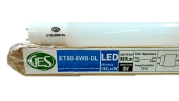  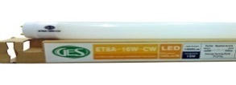 | 363 | 436 | 489.75

BULBS
TEOS-3WH  3W / E27  Daylight  Warm White  5 Year warranty | 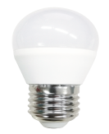 | 203 | 243 | 274.75
TEOS-6WH  6W / E27  Daylight  Warm white  5 Year warranty | 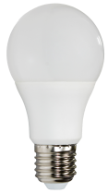 | 308 | 374 | 419.75
TEOS-9WH  9W / E27  Daylight  Warm White  5 Year warranty |  | 394 | 473 | 529.75
TLRQ-3WQ  3W/E14  Daylight  Warm white  5years warranty | 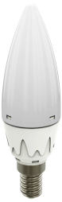 | 190 | 228 | 259.75

WECH-5WY  5W/E27  Daylight  Warm white  5years warranty | 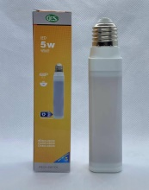 | 434 | 524 | 579.75
WECH-8WY  8W/E27  Daylight  Warm white  5years warranty | 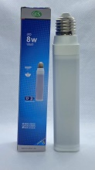 | 583 | 700 | 784.75
WPSH-3W  3W/PL-S  Daylight  Warm white  5years warranty | 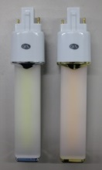 | 381 | 459 | 509.75
WPCH-5WY  5W/PL-C  Daylight  Warm white  5years warranty | 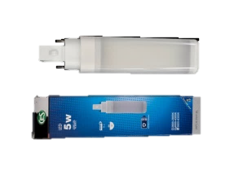 | 434 | 521 | 579.75
WPCH-8WY  8W/PL-C  Daylight  Warm white  5years warranty | 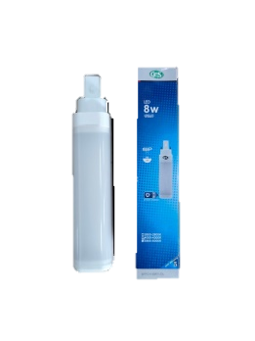 | 583 | 700 | 784.75
WPCL-9W  9W/E27  Cool White  Warm white  5years warranty | 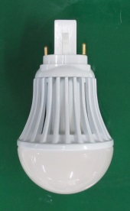 | 404 | 485 | 549.75

MR 16 & GU10
TMR-2WQ  2W/MR16  Daylight  Warm White  5years warranty | 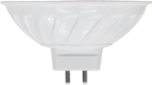 | 184 | 221 | 249.75
TMR-4WQ  4W/MR16  Daylight  Warm White  5years warranty |  | 287 | 344 | 384.75
TMR-6.5WQ  6W/MR16  Daylight  Cool White  Warm White  5years warranty |  | 375 | 450 | 500.75

DOWNLIGHTS (PLASTIC)
WX4B-5.5W  5.5W/4 inches  Warm white  5years warranty | 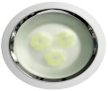 | 483 | 579 | 644.75
WX4B-5.5WH  5.5W/4 inches  Daylight  5years warranty | 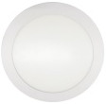 | 483 | 579 | 644.75
WX6B-5.5W  5.5W/6 inches  Daylight  Warm white  5years warranty | 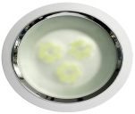 | 567 | 680 | 754.75
WX6B-9WH  9W/6 inches  Daylight  Warm white  5years warranty | 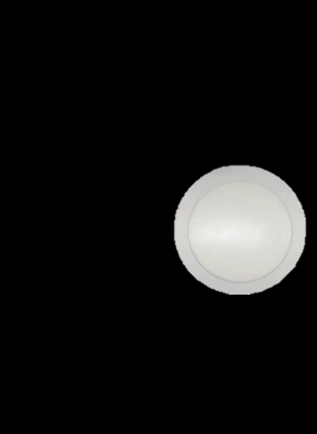 | 637 | 765 | 894.75
WX8B-12W  12W/8 inches  Warm white  5years warranty | 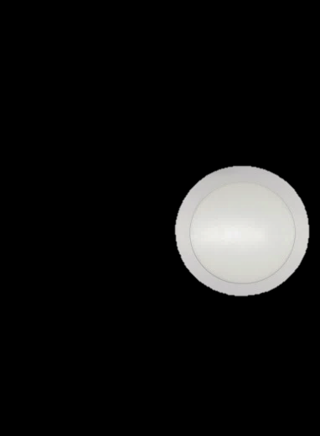 | 850 | 1,020 | 1,134.75
WX8B-12WH  12W/8 inches  Daylight  5years warranty | 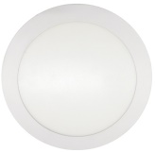 | 850 | 1,020 | 1,134.75

SQUARE DOWNLIGHTS
WX4D-5.5W  5.5W/4 inches  Daylight  Warm white  5years warranty | 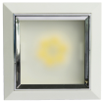 | 506 | 607 | 674.75
WX8D-12W  12W/8 inches  Daylight  Warm white  5years warranty | 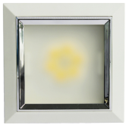 | 968 | 1,161 | 1,294.75

FIXTURE
YT8DS-0.6MB |  | 86 | 103 | 114.75
YT8DS-1.2MB |  | 102 | 122 | 134.75

ADAPTORS AND CONNECTORS
PL-C to E27/  PLS to E27 | 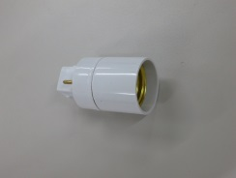 | 66 | 80 | 89.75
E40 TO E27 | 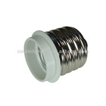 | 60 | 72 | 80.00
E14 TO E27 | 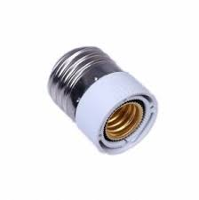 | 50 | 60 | 69.75
PL-4pin to E27 | 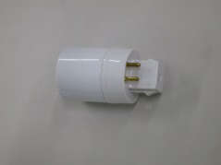 | 66 | 80 | 89.75
1E27 to 2E27 | 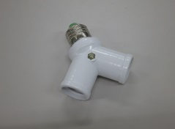 | 79 | 95 | 104.75
1E27 to 3E27 | 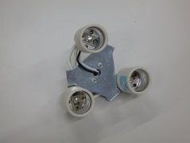 | 210 | 252 | 279.75
1E27 to 5E27 | 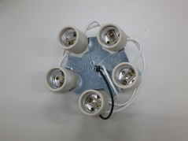 | 274 | 329 | 369.75
MR16 SOCKET

3 YEARS WARRANTY
LP20-5WB  5W/E27  Wide Flood  Daylight  3years warranty | 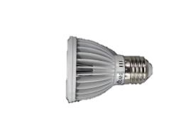 | 413 | 495 | 554.75
LP20-5WA  5W/E27  Wide Flood  White  3years warranty | 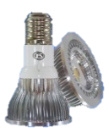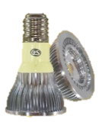 | 413 | 495 | 554.75
LP30-10WB  10W/E27  Wide Flood  Daylight  3years warranty | 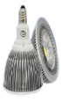 | 965 | 1,158 | 1,289.75
LP30-10WBZ  10W/E27  Wide Flood  WarmWhite  3years warranty | 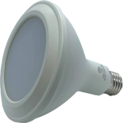 | 965 | 1,158 | 1,289.75
LP30-10WA  10W/E27  Spot  Daylight  Cool White  3years warranty |  | 965 | 1,158 | 1,289.75
LP38-18WB  18W/E27  Wide Flood  Daylight  3years warranty |  | 1,360 | 1,632 | 1,814.75
LP38-18WB  18W/E27  Wide Flood  Daylight  Warm white  3years warranty |  | 1,360 | 1,632 | 1,814.75
LP38-18WA  18W/E27 SPOT  Daylight  Warm white  3years warranty |  | 1,360 | 1,632 | 1,814.75
LA111-12WB  12W/AR111  Wide Flood  Daylight  Warm white  3years warranty | 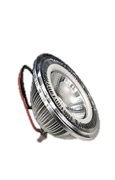  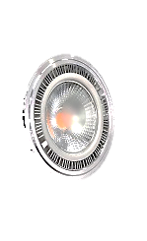 | 1,041 | 1,249 | 1,389.75
LA111-12WA  12W/AR111 SPOT  Daylight  Warm white  3years warranty | 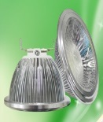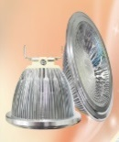 | 1,041 | 1,249 | 1,389.75

2 YEARS WARRANTY
HECM-1WL  E27 – frosted  Daylight  Cool White  Warm White | 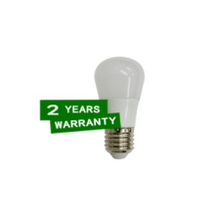 | 90 | 108 | 119.75
HECM-3WL / TECM-3WL  E27 – frosted  Daylight  Cool White  Warm White | 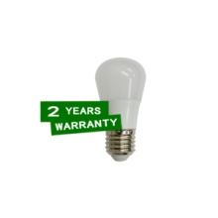 | 97 | 117 | 129.75
HECM-5WL/ TECM-5WL  E27 – frosted  Daylight  Cool White  Warm White |  | 124 | 148 | 164.75
HECM-7WL/ TECM-7WL  E27 – frosted  Daylight  Cool White  Warm White |  | 150 | 180 | 199.75
HECM-9WL/ TECM-9WL  E27 – frosted  Warm White |  | 180 | 216 | 239.75
HSCQ-12WL  E27 – Frosted  Cool White  Warm White | 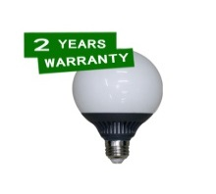 | 529 | 634 | 704.75
HSCQ-18WL  E27 – Frosted  Warm White | 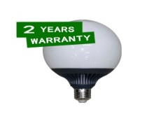 | 686 | 823 | 914.75
HSCQ-25WL  E27 – Frosted  Cool White  Warm White | 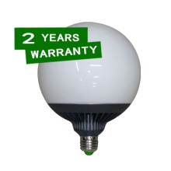 | 814 | 976 | 1,084.75

RESIDENTIAL CIRCULAR LAMPS
YHSA9-10WEL  E27 – 210mm  frosted  Daylight  Warm White | 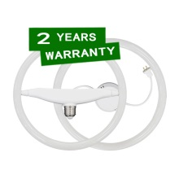 | 575 | 690 | 769.75
YHSA9-10WQL  G10Q – 210mm  frosted  Daylight  Warm White | 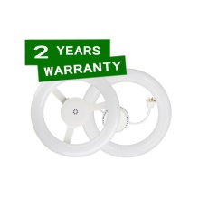 | 575 | 690 | 769.75
YHSD5-12WEL  E27 – 245mm  frosted  Daylight  Warm White |  | 616 | 739 | 824.75
YHSD5-12WQL  E27 – 245mm  frosted  Daylight  Warm White |  | 616 | 739 | 824.75
YHSB9-16WEL  E27 – 290mm  frosted  Daylight  Warm White |  | 794 | 953 | 1,059.75
YHSB9-16WQL  G10Q – 290mm  frosted  Daylight  Warm White |  | 794 | 953 | 1,059.75

RESIDENTIAL CEILING LIGHTS
YXSA-9WL  LED driver  Frosted  Daylight  Warm White | 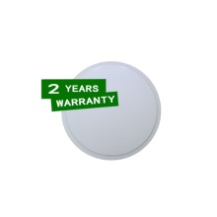 | 424 | 509 | 564.75
YXSB-12WL  LED driver  Frosted  Daylight  Warm White | 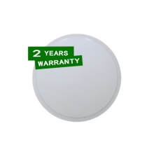 | 479 | 575 | 639.75
YXSC-15WL  LED driver  Frosted  Daylight  Warm White | 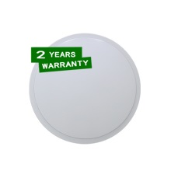 | 534 | 641 | 714.75
YXSD-18WL  LED driver  Frosted  Warm White | 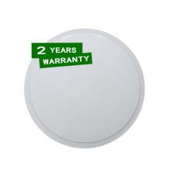 | 616 | 739 | 824.75
YXSE-32WL  LED driver  Frosted  Daylight  Warm White | 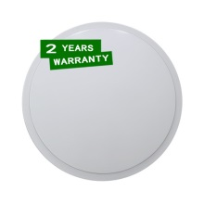 | 944 | 1,133 | 1,259.75

RESIDENTIAL ROUND & SQUARE DOWNLIGHTS
YX3B-4WL  w/ LED driver  3 inches - Frosted  Daylight  Warm White | 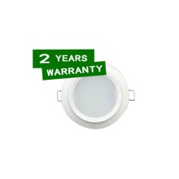 | 262 | 315 | 349.75
YX4B-6WL  w/ LED driver  4 inches - Frosted  Warm White | 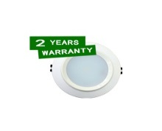 | 330 | 396 | 439.75
YX6B-10WL  w/ LED driver  6 inches - Frosted  Warm White | 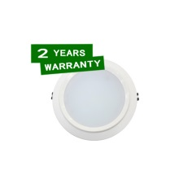 | 472 | 567 | 629.75
YX8B-16WL  w/ LED driver  8 inches - Frosted  Daylight  Warm White | 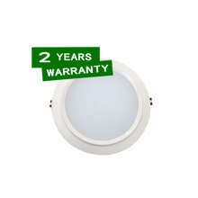 | 656 | 787 | 874.75
YX4D-6WL  w/ LED driver  4 inches - Frosted  Daylight  Warm White | 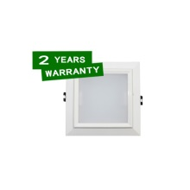 | 330 | 396 | 439.75
YX6D-10WL  w/ LED driver  6 inches - Frosted  Daylight  Warm White | 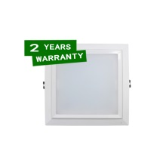 | 487 | 585 | 649.75
YX8D-16WL  w/ LED driver  8 inches - Frosted  Daylight  Warm White | 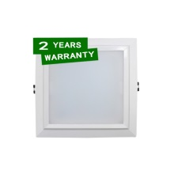 | 682 | 819 | 909.75

RESIDENTIAL SPECIAL BULBS
YECH-3WL  E27 rotatable  Frosted  Daylight  Warm White | 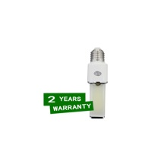 | 251 | 301 | 334.75
YECH-5WL  E27 rotatable  Frosted  Daylight  Warm White | 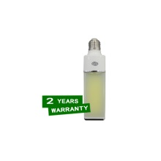 | 289 | 346 | 384.75
YECH-8WL  E27 rotatable  Frosted  Daylight  Warm White |  | 394 | 472 | 524.75
YPSH-3WL  PL-S rotatable  Frosted  Daylight  Warm White | 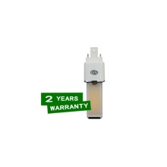 | 251 | 301 | 334.75
YPCH-5WL  PL-C rotatable  Frosted  Daylight  Warm White | 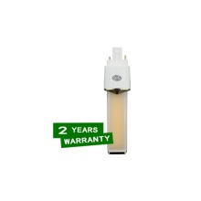 | 289 | 346 | 384.75
YPCH-8WL  PL-C rotatable  Frosted  Daylight  Warm White | 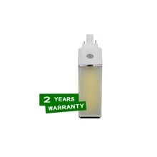 | 394 | 472 | 524.75

1 YEAR WARRANTY
BULBS (E27 & E14 BASE)
MEOQ-3WTH  3W/ E27  Daylight  Warm white  1year warranty |  | 50.63 | 60.75 | 64.75
MECQ-6WTH  6W/ E27  Daylight  Warm white  1year warranty | 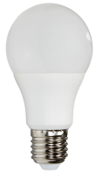 | 74.81 | 89.78 | 99.75
MECQ-9WTH  9W/ E27  Daylight  Warm white  1year warranty |  | 89.81 | 107.78 | 119.75
MECQ-12WTH  12W/ E27  Daylight  Warm white  1year warranty |  | 140.63 | 168.75 | 189.75
MECQ-15WTH  15W/ E27  Daylight  Warm white  1year warranty |  | 168.50 | 202.50 | 224.75
MECB-20WTH  20W/ E27  Daylight  Warm white  1year warranty | 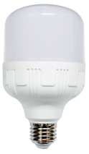 | 292.31 | 350.78 | 389.75
MECB-30WT  30W/ E27  Daylight  Warm white  1year warranty |  | 412.31 | 494.78 | 549.75
MLTQ-3W5TQ  3.5W E14  Daylight  Warm white  1year warranty | 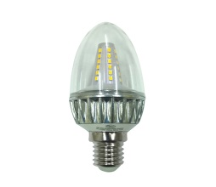 | 74.80 | 89.50 | 99.75

TUBE LIGHT (T8 & T5)
MY8B-9WT  8W/T8/0.6M  Daylight  Warm white  1year warranty | 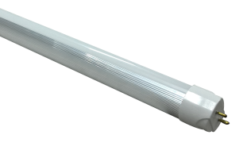 | 149.71 | 179.78 | 199.75
MY8A-18WT  18W/T8/1.2M  Daylight  Warm white  1year warranty |  | 179.81 | 215.H78 | 239.75
MT5BY-9WTQ  9W/T5/0.6M  Daylight8  Warm white  1year warranty | 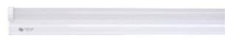 | 198.56 | 238.28 | 264.75
MT5DY-14WTQ  14W/T5/0.9M  Daylight  Warm white  1year warranty | 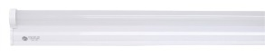 | 221.06 | 265.28 | 294.75
MT5AY-18WTQ  18W/T5/1.2M  Daylight  Warm white  1year warranty | 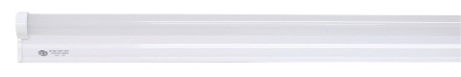 | 239.81 | 287.78 | 319.75
MY5EY-5WTQ  5W/T5/0.3M  Daylight  Warm white  1year warranty |  | 131.25 | 157.50 | 175.75

ROUND DOWN LIGHT
ZX4B-9WT  9W/4 inches  Daylight  Warm White  1year warranty | 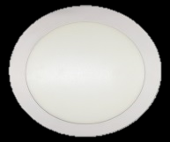 | 225.00 | 270.00 | 299.75
ZX6B-15WT  15W/6 inches  Daylight  Warm White  1year warranty | 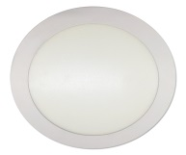 | 322.00 | 387.00 | 429.75
ZX8B-24WT  24W/8 inches  Daylight  Warm White  1year warranty | 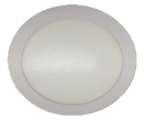 | 397.00 | 477.00 | 529.75

TMF
TMF60-43W | 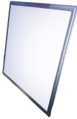 | 3,066 | 3,680 | 4,088.75
TGU-4WQ-WW  GU10 4W  Warm White  5 years warranty | 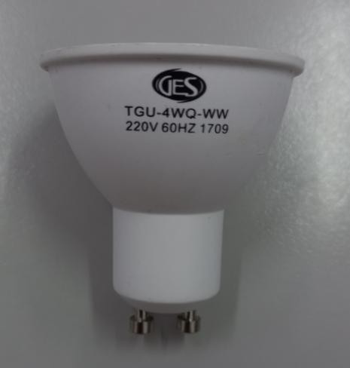 |  | 344.00  Ayala price/bonifacio high street
TLG-120W  Streetlight  120W  Cool White  5 Years Warranty | 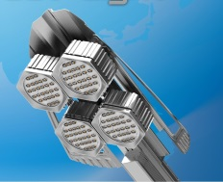 |  | PHP 16,965.  ROXAS SEAFRONT GARDEN HOME OWNERS ASSO. INC

